

Medinova
Case Study
Scenario

- Introduction
Medinova is a new approach to providing managed health care for private patients in Australia. Medinova was formed by a merger of OzMedInsure, an entrepreneurial private health insurance fund and Amalgamated Private Hospitals, a group of under performing private hospitals. They also bought out the AustLocums chain of 24 hour clinics, which were also suffering financially, and the Ozziepharm franchised pharmacies.
The objective of Medinova is to provide managed hospital and medical insurance but reduce operating and payout costs by owning the medical delivery channels to secure stable business volume through bulk employer sponsorships of membership schemes. The strategic business vision is to create a one-stop health care environment.
The group has now been operating with marginal profitability for three years with each division still separately managed and accounted for on separate balance sheets. While the business outcome so far, has fallen short of the early five year projections, the group management believes that the enterprise can reach the original targets and return profits to investors by the fifth year, while offering employers and patients a better value proposition than available through conventional private medicine arrangements.
The Corporate Board has approved the directive to establish an Enterprise Architecture program within the company to address the strategic goals of the company. An architecture board has been established and they have adopted the TOGAF 9 Framework and Architecture Development Methodology. An Architecture team has been established which is sponsored by the CIO, some preliminary work has been completed to establish the Enterprise Architecture practice.
As an external consultant, you have been asked to deliver an architectural review recommending a programme of activities that will address Medinova’s business problems. The CIO has provided the following information about Medinova.

- Operations
There are five businesses in the group administered by Head Office.
- Insurance business
- Sydney Hospitals business
- Melbourne Hospitals business
- 24 hour clinics
- Pharmacies

Medinova also plans to provide dental services in line with its strategy of delivering a one-stop health care package.

Head Office
The Head Office is located in Sydney, in the premises of the insurance business. The current major Head Office functions are to ensure that the group as a whole remains profitable, and that each business at least breaks even. It is a key management guideline that for the business as a whole to produce a worthwhile return to shareholders, there is to be no cross-subsidization. This current philosophy allows each business to largely operate as independent divisions with each division providing the full range of normal business functions as well as specialized functions required for that business, example Practice Management in Clinics.
HO understands that they need monthly feeds from each business unit to produce monthly consolidated reporting. The current quarterly feeds provide financial management data that is up to 6 months out of date. This is hampering efforts to improve group profitability through better management of the individual businesses. HO also realize there is potential to improve the profitability of each business by taking a more direct hand in managing of costs and applying economies of scale. HO has also begun marketing the one-stop package to large and smaller businesses as employer-sponsored health care included in the insurance package. This also provides an opportunity to cross-sell their other insurance products and superannuation products. They have recently achieved status as a Government approved ‘Workcover’ insurer.
Group financial management is done from a single PC with a commercial accounting package MyAccount and spreadsheets, and quarterly reports from each of the constituent businesses. Because of numerous data problems, Feeds from the Pharmacy and Clinics businesses are consolidated in a spreadsheet and reconciled before they are loaded to the MyAccount application. Other businesses feed directly to the MyAccount application through an FTP link and loaded by batch.
Head Office provides the following services.
- Corporate Governance
- Strategy (Direction, Governance, Planning)
- Finance and Accounting
- HR Management
- IT Management
- Facilities Management (of office premises etc.,)

Insurance Business
The insurance business has a base of Superannuation and Life insurance, but also offers hospital, extras, life, critical illness and income continuity insurance cover. The insurance business is the oldest, and the driver of the consolidation. It has always been profitable in the areas of superannuation and life insurance. Subsequently it entered the area of health insurance, which has always been difficult, and also became a government workcover insurer, a field where it is possible to operate profitably with recent government reforms to the claims structure.
Because of the reliance on packages, no great attention has been focused on data architecture. The primary key to all records is the policy number, and while other searches are available to the small call center, there is no concept of ‘customer’ to use across all parts of the group business.
The IT environment is based on an IBM Power 740, running a commercial general Ledger package JDEdwards GL, an insurance package (Acme Life), their legacy private health package (Medi-Benefits), and SAP for ERP functions including HR. There is an Oracle database supporting the packages, and an Oracle Data Warehouse providing marketing, MIS and Financial accumulation which is fed into the General ledger. The general office systems are provided by a Wintel server supporting 25 desktop PCs running MS-Office, including Outlook. There are 5 traveling salesmen who use stand-alone laptops on customer sites. These salesmen have been clamoring for on-line access to HO systems while at customer sites, but this has not been provided on cost-grounds.
The Insurance Business provides the following services.
- Business Governance
- Strategy (Direction, Governance, Planning)
- Finance and Accounting
- HR Management
- IT Management
- Facilities Management (of office premises etc.,)
- Product Development
- Product (Policy) Administration
- Underwriting
- Claims

Private Hospitals Business
The hospital business operates a number of private hospitals. The three Sydney private hospitals each run their own computer systems based on HP-Unix (HP UX) running generic hospital management packages (Hospit), SAP for materials logistics and HR and PC workstations from a Windows NT server. They use a separate EFTPOS link to take credit card payments with manual reconciliation. These hospitals have a panel of existing specialists, whose business they would not wish to lose. These surgeons charge higher than the norm, and are seen as unlikely to want to work at discounted or packaged rates. These hospitals also encourage cosmetic surgery patients, who are always profitable, despite no Medicare and minimal private insurance support.
As in all hospitals, patients are tracked per admission with a ‘UR’ number, which is also used to identify their records, retained for some years after the admission. The number is unique per hospital.
The private hospitals currently offer discounts to Medinova insurance customers.
The two hospitals in Melbourne use a bureau service provided by an outsourcing agency (HCS) for Hospital management, inventory management, HR and payroll management and Financial management and accounting. These hospitals have a reputation for no-frills solid basic care, The EFTPOS payments system is linked directly to the bureau, for direct updates to accounts receivable.
The Hospitals Business provides the following services.
- Business Governance
- Strategy (Direction, Governance, Planning)
- Finance and Accounting
- HR Management
- IT Management (Sydney Only)
- Facilities Management (of office premises etc.,)
- Hospital Management
- Inventory Management

Clinics Business
All clinics and pharmacies are co-located, but use separate systems.
Clinics use a windows based vertical market package (PMS) for patient management, records and accounts, with the main entry point being by surname or Medicare number.
The clinics are suffering with changes to government bulk-billing rules and requirements for ongoing doctor training and accreditation.
The clinics provide access to specialists at discounted rates to patients insured with Medinova.
The clinics use Wintel server with thin client workstations in each consulting room. Financial consolidation and reporting is done by quarterly summary feeds (emailed spreadsheet) from each business unit that is consolidated into the accounting system at HO for management and financial reporting.
The Clinics provides the following services.
- Business Governance
- Strategy (Direction, Governance, Planning)
- Finance and Accounting
- HR Management
- IT Management
- Facilities Management (of office premises etc.,)
- Practice Management

Pharmacies Business
Pharmacies are co-located with the clinics and provide prescription drugs, customer available treatments and medical supplies. Pharmacies offer discounts on non-prescription products, and additional discounts for prescription drugs obtained by Medinova private health insurance customers.
Although co-located with the clinics the pharmacies use separate PCs in the dispensary, and a separate checkout system. The Pharmacies use a windows-based vertical market package (Pharmsys) software on separate systems to the clinics. The Pharmsys application provides customer details, records of dispensation and payment collection, accounts and inventory control. Customer records are identified by surname or Government Medicare number.
Financial consolidation and reporting is done by quarterly summary feeds (emailed spreadsheet) from each business unit that is consolidated into the accounting system at HO for management and financial reporting.
The Pharmacies provides the following services.
- Business Governance
- Strategy (Direction, Governance, Planning)
- Finance and Accounting
- HR Management
- IT Management
- Facilities Management (of office premises etc.,)
- Inventory Management

- Concerns
- There is no clear concept of ‘customer’ across the group. As the group’s mission is now primarily profitable managed health care this is a major flaw in the data and business architectures, as no ready measures of income per customer are available across the group.
- Recent privacy legislation complicates use of customer information in any case, and an analysis is required of these implications, for preparation of a privacy statement.
- Financial reporting is required at least on a monthly basis to be of operational and tactical use
- There is no total business architecture on which to base and manage operation of the group as a whole
- Hospitals use different applications packages
- Each business within the group uses different applications packages. There is no basis achieving economies of scale in materials and resource purchasing or management, neither for cost management nor for cross-selling services to identified customers.
- None of the infrastructure currently supports operations within an integrated business model.

- Business Roles
Organisation | Role | Name | Comment/Concerns
Head Office | Group CEO | Ralph McGee | Needs high level cost and design for Board
 | Group CFO | Bianca Tay | Likes numbers, concerned about costs and how reporting will operate
 | Group CIO | Robert North | Wants to simplify environment, concerned about Risks. Likes graphics.
 | Group HR director | Belinda Dawson | Concerned about impact on staffing and skills
 | Group Operations | Amanda Rossi | Cost of operations, How reporting will operate.
 | Group Strategy | Nigel Tuckworth | Wants to see how solution meets strategic objectives.
 | Programme management | Lucy Wong | Reducing Risk, availability of resources, How changes will be rolled out.
 | Manager Financial reporting Unit | Michael Jackson | How the new reporting will operate. When it will be implemented and cost.
Insurance Sydney | CEO | David Baker | High level cost and design.
 | CFO | Ian Street | Costs and how reporting will operate.
 | HR | Kay Butler | Impact on staffing and skills
 | IT Manager | Alan Parson | Concerned his dept will be outsourced. May undermine solution
 | Head insurance operations | Wendy Masterton | Concerned about remote sales access.
 | Claims manager | Bradley Jenkins | No particular interest in programme.
 | Strategy manager | Kelly Low | Concerned about remote sales access
Sydney Hospitals | CEO | Heinrich Mueller | High level cost & design. Wants Sydney operations duplicated for Victoria
 | CFO | Bob Taggert | Costs and how reporting will operate
 | HR Manager | David Spencer | Impact on staffing and skills
 | Operations Manager | Paul Chang | Wants Operations based on Sydney hospital and may disrupt alternatives. Close friend of Group Operations Manager.
 | Inventory manager | Susan Lovegrove | Very new to company, supports change wants to centralize Inventory
 | IT manager | Karen Spencer | What new technology services required.
 | Doctors |  | No interest
 | Medical support staff |  | Concerned about added workload
Melbourne Hospitals | CEO | Helen Hunter | Wants solution based on Victoria solution. Interested in cost and design.
 | CFO | Robert Motram | Costs and how reporting will operate
 | HR Manager | Anna DeSilva | Impact on staffing and skills
 | Operations Manager | Nalatie Baker | Changes to business services across group, well respected across group.
 | Inventory manager | Lars Nordstrom | Key proponent of economies of scale, likes diagrams. Interested in Operational changes to inventory.
 | Doctors |  | No interest
 | Medical Support staff |  | No interest
Clinics | Clinic Manager | David Nguyen | Poor reputation, Very interested in Single customer view
 | Operations & Inventory manager | Albert Webb | Supports moving part of his responsibility to Head Office. Concerned about timing and workload of implementation
 | Support staff |  | Have complained to union about potential job losses. Concerned about workload.
Pharmacy | Pharmacy manager | Ajay Kumar | Likes diagrams, Wants to see what new functionality will be provided.
 | Pharmacists |  | Interested in changes to applications, how it will integrate with other systems.
 | Support staff |  | Have complained to union about potential job losses. Concerned about workload.
 | Operations & Inventory manager | Wallace Whitworth | Concerned about job. Does not support changes.

The CIO has informed you informally that the businesses are very independent, particularly the Insurance business which considers itself the leading company in the group. The staff members of the insurance business see themselves as carrying the whole group in terms of performance and are resistant to their operations changing. They have experience in running programmes, and redefining their own processes, they believe they can be the model for the group.
The Hospital businesses are extremely competitive with each other, both considering that they run the better operation. While they appreciate the need for change, they each think that operations should be based on them. HCS (the Melbourne hospital outsourcer) has been very active in promoting its services to Head Office Group Operations Manager.
The Clinics and Pharmacies run on a very tight budget. They run in reactive mode not having enough resources to perform any activity outside of day to day operations. The Support staff members in the Clinics and Pharmacies are stretched to support day to day needs. Because salaries are at the low end of the range, the non-medical staff are not highly skilled and lack extensive experience. All non-professional staff across Hospitals, Clinics and Pharmacies are represented by the Medical Service Staff Union (MSSU) who are concerned about potential job losses for members.

- To-Be Architecture
Head Office Function manages performance of the entire business, issues targets and macro-manages the individual business units. HO also controls the business strategy, capital expenditure and information systems.
HO wish to introduce economies of scale in purchasing supplies for the hospitals and clinics, many of which apply to both (bandages, disinfectants etc). They want to introduce common ERP HR across all businesses.
A second major priority is to introduce the concept of a ‘customer’, who is identified in all of the business systems. This is seen as a key enabler of the ‘one-stop-shop’ concept, which is critical to the group’s strategy.
Thirdly, they would like all hospitals, including the ones in Victoria, to operate on the same IT system to improve logistic and financial reporting.
All IT systems are based on packages specialised to address the special niche nature of each business unit. There are no funds to replace or rework any existing IT infrastructure, but some funds are available to enhance the IT applications and infrastructure to support integration of the management function. In particular, up-to-date reporting across the business is mandatory, but no package is available to achieve this.

- Principles
Accept the following Principles have been set:
- Reuse existing enterprise assets before buy before build
- Outsource non-core business (service units)
- Integrate existing systems
- Standardise on applications
- Provide a single view of the customer
- Provide a single view of truth and stewardship
- Information will be protected in line with legislation

- Constraints
- The group is prepared to invest $2,000,000 to implement an integration solution that will allow optimal management and profitability over the next 5 to 10 years.
- The planning work must be completed within 3 months.
- The design must adhere to the current business principles and architecture principles.
- The architecture investment is limited to $100,000
- The solution investment will be limited to $500,000
- Any solution must comply with the following acts and regulations.
  - Business and Architecture principles and standards
  - Health insurance regulations
  - Consumer protection regulations
  - Privacy regulations
  - Occupational health and safety acts in each state.
- The EA team will have the following resources available:
  - The architects within the team
  - M Jackson, Manager Financial Reporting Unit (FRU) 2 day a week
  - Nigel Tuckworth, Group Strategic Planner – 1 day a week

- Medinova MetaModel
The Architecture board has approved the adoption of the organisational Meta-model based on the TOGAF standard definition.

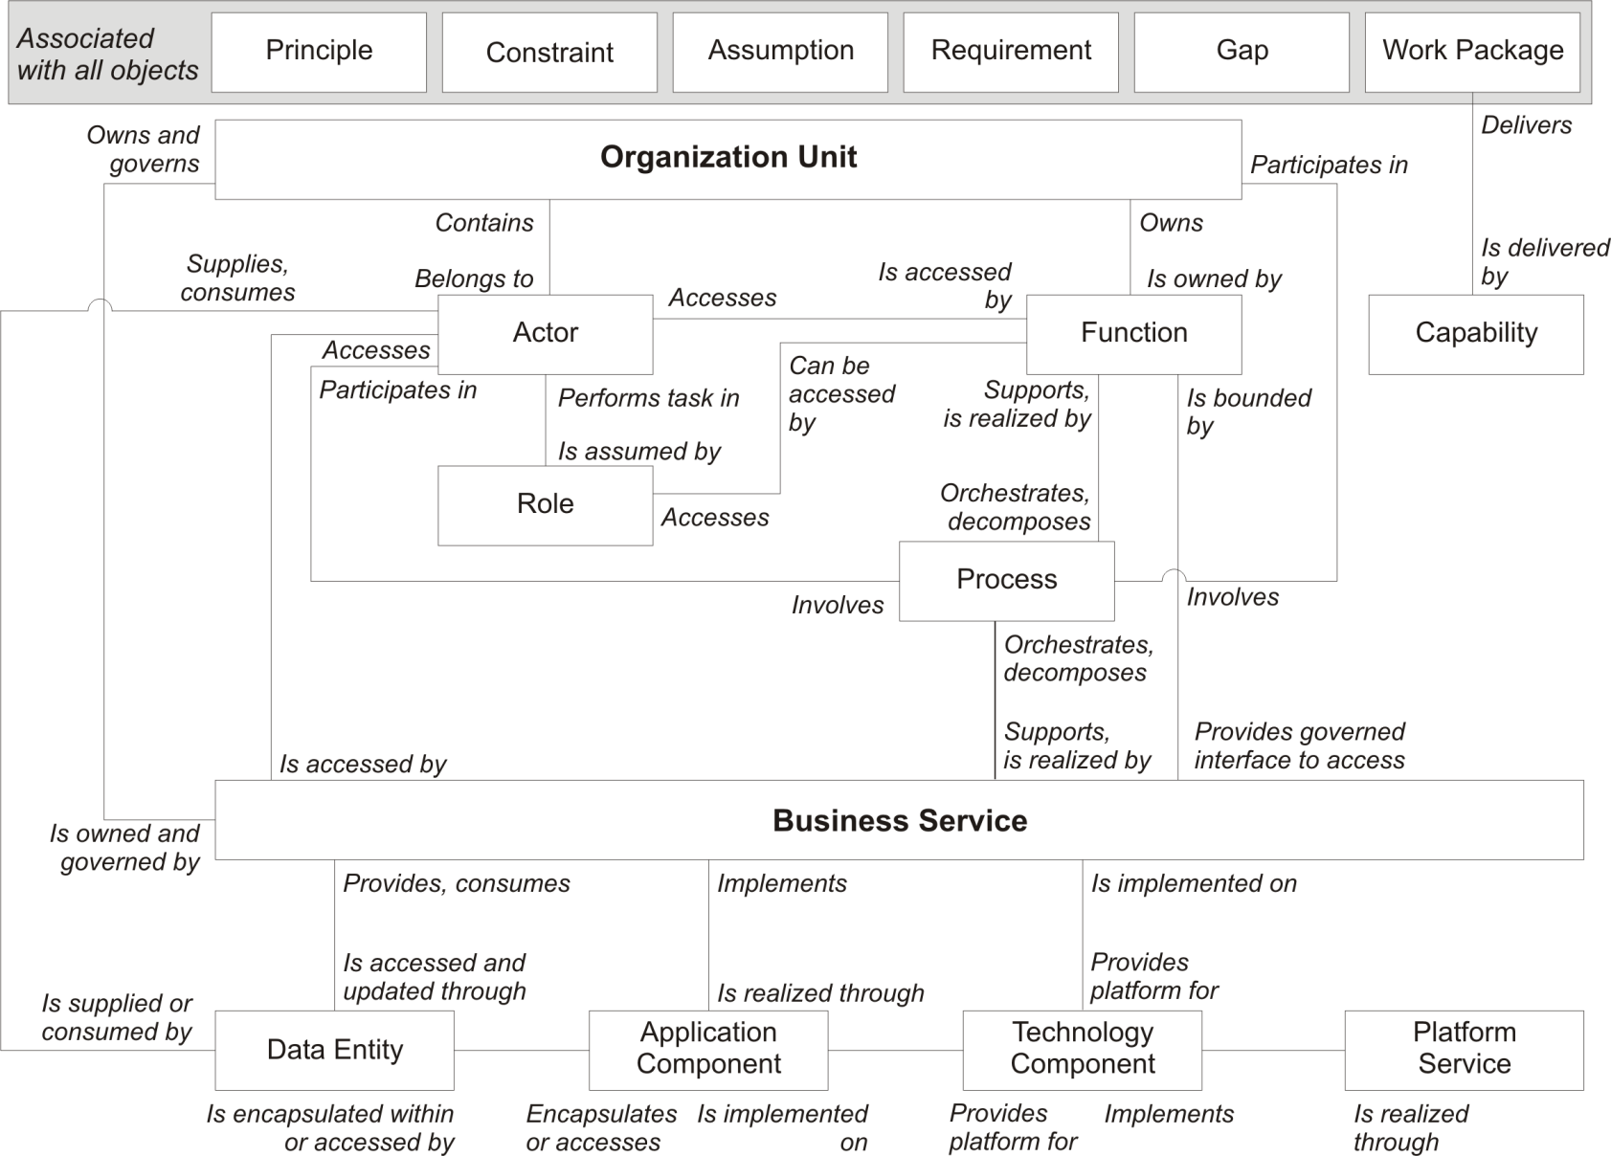

Scenario Questions
Using the information provided in the scenario you will be asked to answer a number of questions that are based on different phases of the Architecture Development Methodology (ADM). The information provided has been deliberately constructed so that the scenarios provide a range of information. The scenario contains relevant information for the questions but also includes irrelevant information, in some instances there may be insufficient information to provide a clear answer. This is typical of the first round of information collection and analysis.
Please note that there are no single correct answer for the exercises. Students should however provide some basis or reasoning behind their answers. Students may make assumptions (where the scenario is not clear) but should record the assumptions on which the answers are based. Students should also identify areas that require further investigation.

